**A PROJECT REPORT ON**

**TaskFlow: A Smart Task Management System**

**Submitted By**

**Thanki Chirag Jitendrakumar**

**(Enroll No.: R24014201004963210031)**

**Guided By**

**Dr. Jyotsna Salet**

**In fulfillment for the award of the degree**

**of**

**Master of Science in Information Technology**

**In**

**Computer Department**

**Shri V. J. Modha College of I.T, Porbandar**

**Bhakt Kavi Narsinh Mehta University, Junagadh**

**Oct 2025**



**Acknowledgement**

• I am sincerely grateful to all those who contributed towards the completion of this **TaskFlow: A Smart Task Management System** project developed using **Node.js** & **MongoDB** Database. This project would not have been possible without the guidance and support of many individuals.

• First and foremost, I would like to thank **Dr. Jyotsna Salet** for his invaluable guidance, insightful feedback, and constant encouragement throughout the course of this project. Their expertise and suggestions were instrumental in the successful implementation of this system.

• I would also like to express my gratitude to my peers and fellow classmates who provided constructive feedback and motivation during challenging times. Their input was vital in refining the project's features and improving its functionality.

• It is my great pleasure to represent my project as web app titled “Task Flow: A Smart Task Management System” which done in semester-3 of MSc (IT & CA), affiliated to BKNMU (Bhakta Kavi Narsinh Mehta University).

• Additionally, I am thankful for the availability of various online resources and forums that offered technical insights and solutions to the issues I encountered during the development process.

• Lastly, I would like to extend my appreciation to my family for their unwavering support and understanding while I dedicated time to this project. Their encouragement helped me stay focused and motivated.

**INDEX**

Table of Contents

1 Table of Contents 3

1 Project Profile 5

1.1 Purpose 5

1.2 Scope 6

1.3 Objective 8

2 Requirement Analysis 10

2.1 Problem Definition 10

2.2 Process Model 12

2.3 Grant Chart 15

3 System Diagram 16

3.1 Data Flow Diagram 16

3.1.1 DFD-Level-0 16

3.1.2 DFD-Level-1 17

3.2 E-R (Entity-Relationship) Diagram 18

3.3 Use-Case Diagram 19

4 Data Dictionary 20

4.1 Tables 20

5 User Interface (FrontEnd) 23

5.1 Home Page with Task 23

5.2 Home Page (Add Task) 24

5.3 Home Page (Added Task) 25

5.4 Home Page (Multiple Tasks Added) 26

5.5 Home Page (Completed Tasks) 27

5.6 Home Page (Edit/Update Tasks) 28

5.7 Home Page (My Link Highlighted) 29

5.8 Home Page (Tasks List with done tasks) 30

6 Server-Side (BackEnd) 31

6.1 Server.js (Node.js server file): 31

6.2 app.js (Node.js server file): 34

6.3 index.ejs (FrontEnd file): 35

7 Database (MongoDB): 43

8 Budget and Financial Plan 45

9 Future Enhancements 46

10 Limitations 49

11 Conclusion 51

12 Bibliography 52

13 References 53

13.1 Sites: 53

# Project Profile

## Purpose

The purpose of this project, *TaskFlow: A Smart Task Management System*, is to provide users with an efficient platform to create, manage, and organize their daily tasks. The system is designed to simplify task handling through a web-based application built using **Node.js** for the backend and **MongoDB** as the database.

This system allows users to perform **CRUD operations (Create, Read, Update, Delete)** on their tasks, ensuring flexibility and control in managing their schedules. By using TaskFlow, users can:

* Maintain a structured list of tasks.
* Update progress and modify tasks as required.
* Delete completed or irrelevant tasks.
* Access their data securely with database storage.

The main purpose is to reduce the manual effort of tracking tasks and to enhance productivity by providing a smart, digital solution that is user-friendly, scalable, and efficient.

## Scope

The scope of this project, **“TaskFlow: A Smart Task Management System,”** is to design and develop a web-based application that simplifies the process of managing tasks efficiently. In today’s fast-paced environment, individuals, teams, and organizations require a reliable system that can organize daily activities, assign responsibilities, monitor progress, and ensure timely completion of tasks. This project aims to address these needs by offering a lightweight, scalable, and user-friendly task management solution built with **Node.js** for the backend, **MongoDB** for the database, and CRUD (Create, Read, Update, Delete) functionalities for effective data handling.

The primary scope includes the development of a system where users can **create tasks**, **view tasks**, **update tasks**, and **delete tasks** as per their requirements. Each task may include details such as title, description, due date, priority level, and status. By offering these core features, the system ensures that users can maintain an organized workflow and reduce the chances of forgetting important tasks. The project is designed to be flexible, allowing both individual users and small teams to benefit from the system.

Another important aspect of the project scope is the **integration of MongoDB** as the database. MongoDB is chosen because of its NoSQL structure, flexibility, and ability to handle large amounts of unstructured data. This makes the system scalable and efficient in handling real-world data operations. The use of Node.js as the backend technology provides a **non-blocking, event-driven architecture** that ensures fast processing and seamless user experience.

The scope also extends to creating a **user interface** that is simple, clean, and easy to navigate. Although the main focus of the project is backend functionality and database operations, the frontend will play a crucial role in ensuring that users can interact with the system effortlessly. The design will allow users to filter, sort, and manage tasks without unnecessary complexity.

Beyond the basic CRUD operations, the scope includes implementing **status tracking** for tasks such as “Pending,” “In Progress,” or “Completed.” This feature will help users visualize their progress and stay motivated. Additionally, the system will allow users to set deadlines and priorities, making it possible to distinguish between urgent and non-urgent tasks.

In summary, the scope of **TaskFlow: A Smart Task Management System** is to provide a structured, efficient, and scalable platform for task management. It will cover backend development using Node.js, database management using MongoDB, and implementation of CRUD operations for task handling. The project ensures a balance between simplicity and functionality, making it suitable for both personal productivity and small team collaboration.

## Objective

**Technology Review**

TaskFlow: A Smart Task Management System is built using modern web development technologies to ensure scalability, performance, and ease of maintenance. The backend is developed using **Node.js**, a powerful runtime environment that allows developers to run JavaScript on the server side. Node.js is widely chosen for real-time applications due to its event-driven, non-blocking I/O model, which makes it lightweight and efficient. With Node.js, the system can handle multiple requests simultaneously, making it suitable for a task management system where users perform frequent operations such as creating, updating, and deleting tasks.

For the database, **MongoDB** has been selected. It is a NoSQL, document-oriented database known for its flexibility and high performance. MongoDB stores data in JSON-like documents, making it easier to model and manage complex data structures compared to traditional relational databases. This schema-less nature allows the system to adapt quickly to changes in project requirements without significant redesign. Moreover, MongoDB offers built-in scalability and supports distributed database clusters, which ensures that the TaskFlow system can handle large volumes of data as the number of users grows.

The system primarily implements **CRUD (Create, Read, Update, Delete)** operations, which are the backbone of any data-driven application. CRUD ensures that users can efficiently manage their tasks by adding new entries, retrieving existing data, modifying task details, and removing completed or unnecessary records. These operations are implemented using RESTful APIs in Node.js, providing a structured way to interact with the database. Additionally, frameworks and libraries such as **Express.js** are commonly integrated to simplify server-side development, improve routing, and manage middleware effectively.

To enhance usability, the system may incorporate front-end technologies like HTML, CSS, and JavaScript, or modern frameworks such as React or Angular, depending on the design requirements. This ensures a user-friendly interface where tasks can be managed seamlessly.

**Literature Review**

Task management systems have been widely studied and developed in both academic and industrial contexts. In today’s fast-paced environment, effective task organization is crucial for personal productivity as well as collaborative teamwork. Traditional methods, such as paper-based planners and spreadsheets, often fail to provide real-time synchronization, accessibility, and scalability. As a result, digital solutions leveraging web and cloud technologies have gained popularity.

Research in task management systems emphasizes the importance of intuitive interfaces, real-time synchronization, and flexible data handling. Several existing systems, such as Trello, Asana, and Microsoft To Do, highlight features like drag-and-drop task organization, reminders, and team collaboration. However, many of these platforms are either too complex for small-scale use or restricted by subscription-based models. This creates opportunities for building customized systems tailored to specific needs.

Studies also indicate that integrating task management systems with cloud-based databases improves accessibility and data consistency across devices. MongoDB’s document-based storage model has been noted for its adaptability in managing unstructured or semi-structured data, which is common in task management applications. Node.js, due to its asynchronous nature, has been widely discussed in research for building real-time collaborative tools, including chat systems, project trackers, and task managers.

By combining Node.js and MongoDB, TaskFlow aligns with contemporary research and best practices in software engineering. It offers a balance of efficiency, scalability, and user-friendliness. The literature supports the use of CRUD-based architectures for managing core functionalities, ensuring that users can perform essential task operations reliably.

# Requirement Analysis

## Problem Definition

In today’s fast-paced digital world, managing tasks efficiently has become a critical need for both individuals and organizations. With multiple projects, deadlines, and responsibilities to handle, people often struggle to prioritize tasks, track progress, and ensure timely completion. Traditional methods of task management, such as pen-and-paper lists or basic spreadsheets, are insufficient to meet the dynamic requirements of modern work environments. They lack automation, real-time updates, and the ability to scale with growing workloads, often leading to missed deadlines, decreased productivity, and increased stress.

Existing task management solutions in the market, while effective to some extent, often come with certain limitations. Many are either too complex for beginners or too rigid to adapt to unique workflows. Others fail to provide a comprehensive view of tasks, subtasks, deadlines, and priorities in a single interface. Additionally, a significant challenge is data management; without a robust backend, these systems can suffer from data inconsistency, slow retrieval, and lack of secure storage. For organizations, this can translate into miscommunication between team members, duplication of work, and difficulty in monitoring individual and collective progress.

Given these challenges, there is a clear need for a smart task management system that is intuitive, flexible, and capable of handling CRUD (Create, Read, Update, Delete) operations efficiently. The system should allow users to create tasks, update them as needed, delete completed or irrelevant tasks, and read or retrieve task information whenever required. By integrating a powerful database like MongoDB with a robust backend built on Node.js, such a system can offer real-time data management, seamless user interaction, and secure storage. This integration ensures that tasks are not only managed effectively but also synchronized across multiple devices and accessible to authorized users at any time.

The primary problem this project addresses is the lack of an accessible, efficient, and dynamic platform for managing tasks that can cater to both individual and team requirements. Users need a system where tasks can be categorized, prioritized, and tracked easily, with visual cues and notifications for deadlines. Moreover, the system must support multiple CRUD operations without performance lags, ensuring data accuracy and consistency. The backend database should handle large volumes of task data, supporting scalability as users or teams grow in size and activity.

In summary, the problem lies in the absence of a user-friendly, secure, and responsive task management solution that combines modern web technologies with efficient data management. **TaskFlow: A Smart Task Management System** aims to fill this gap by offering a complete solution for creating, managing, and tracking tasks with ease.

## Process Model

The **process model** of a software system describes the structured flow of tasks, activities, and operations that occur within the system to achieve its objectives. In the case of *TaskFlow: A Smart Task Management System*, the process model defines how tasks are created, managed, updated, and deleted using a structured workflow. This model serves as a blueprint for understanding system behavior and ensures that the system operates efficiently and reliably.

*TaskFlow* is designed using **Node.js** for the backend, which provides an asynchronous, event-driven architecture that efficiently handles multiple requests. **MongoDB** is used as the database to store task information, user details, and other related data in a flexible, document-oriented structure. The CRUD (Create, Read, Update, Delete) operations form the core of the system’s functionality and are carefully integrated into the process model.

The **process model** of TaskFlow can be divided into several key stages:

**1. Task Creation (Create):**

The first step in the process model involves creating new tasks. Users can input task details such as title, description, priority, due date, and status. Node.js handles the incoming request, validates the input, and then interacts with MongoDB to store the task data. The process ensures that all required fields are correctly filled before insertion, maintaining data integrity.

**2. Task Retrieval (Read):**

The next stage involves retrieving tasks from the database. Users can view their tasks in a structured format, filter by status, priority, or deadlines, and search for specific tasks. Node.js sends queries to MongoDB, which fetches the relevant documents and returns them to the frontend. This process ensures that users have real-time access to task information, enabling better planning and productivity.

**3. Task Update (Update):**

Updating tasks is a crucial part of the process model. Users may need to modify task details, mark tasks as complete, or change priorities. Node.js receives the update request, validates the changes, and performs the update operation in MongoDB. The process ensures that modifications are tracked and reflected accurately, maintaining a consistent state of the system.

**4. Task Deletion (Delete):**

The final stage in the CRUD process is task deletion. Users can remove tasks that are no longer relevant. Node.js handles the delete request, and MongoDB performs the deletion from the database. Proper checks are implemented to prevent accidental data loss, ensuring that only authorized deletions occur.

**5. Workflow Management:**

Beyond CRUD operations, the process model incorporates additional workflows such as task assignment, notifications, and reminders. These workflows enhance the system’s intelligence by automatically alerting users about deadlines, task updates, or overdue tasks.

Advantages of Iterative Waterfall Model

* Simple and Easy to Understand and Each Phase has well Defined Input and Output.
* It Work well for Smaller Project Where Requirement Are Clear And very well understood.
* It Divide complex task into more manageable works.

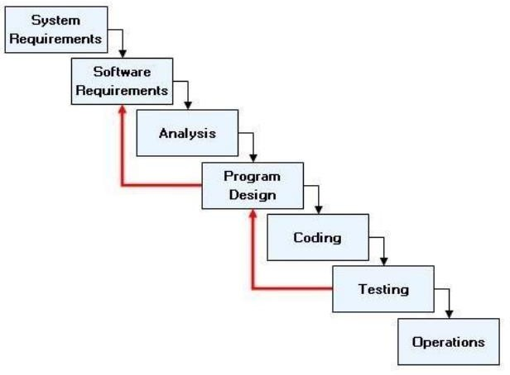

## Grant Chart

|  |  |
| --- | --- |
| **Guide Name: Dr. Jyotsna Salet** | |
| **Date** | **Task** |
| 03-8-2025 | Project Title |
| 10-08-2025 | Information Gathering |
| 17-08-2025 | Table Structure |
| 24-08-2025 | Diagram |
| 31-08-2025 | Form Design |
| 07-09-2025 | Project Validation |
| 14-09-2025 | Half Coding |
| 21-09-2025 | Full Coding |
| 28-09-2025 | Document |
| 30-09-2025 | Project Certificate Issue |
| 30-09-2025 | Final submission with Soft & Hard Copy |

# System Diagram

## Data Flow Diagram

### DFD-Level-0

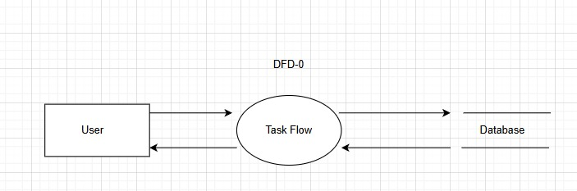

### DFD-Level-1

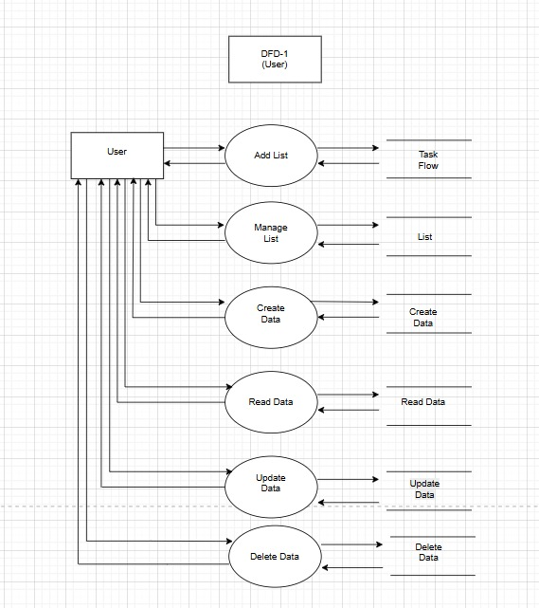

## E-R (Entity-Relationship) Diagram

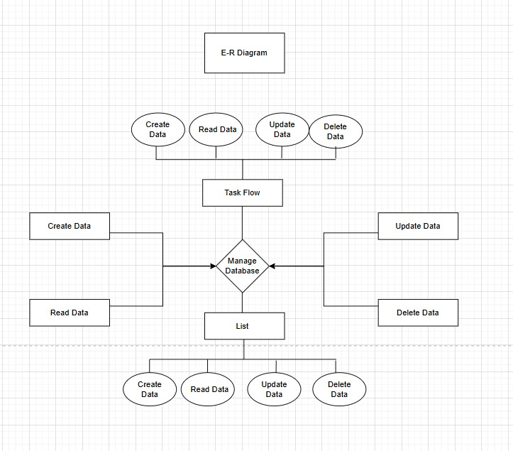

## Use-Case Diagram

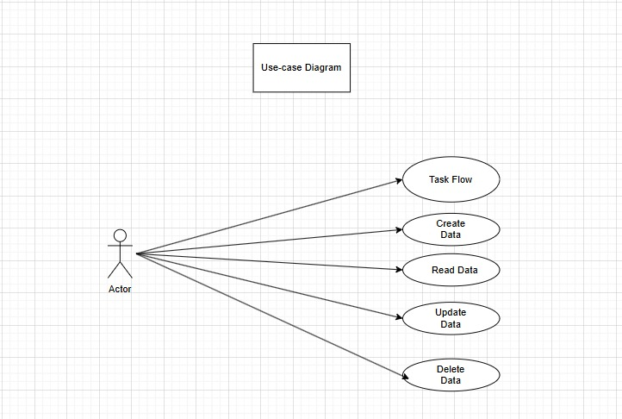

# Data Dictionary

## Tables

**Table-1: Task Flow**

|  |  |
| --- | --- |
| **Field** | **Data Type** |
| **Id** | **Int** |
| **List Name** | **Varchar** |
| **List Read** | **Varchar** |
| **List Update** | **Boolean** |
| **List Delete** | **Varchar** |

**Table-2: List**

|  |  |
| --- | --- |
| **Field** | **Data Type** |
| **Id** | **Int** |
| **List Name** | **Varchar** |
| **List Read** | **Varchar** |
| **List Update** | **Boolean** |
| **List Delete** | **Varchar** |

**Table-3: Create Data**

|  |  |
| --- | --- |
| **Field** | **Data Type** |
| **Id** | **Int** |
| **List Name** | **Varchar** |
| **List Read** | **Varchar** |
| **List Update** | **Boolean** |
| **List Delete** | **Varchar** |

**Table-4: Read Data**

|  |  |
| --- | --- |
| **Field** | **Data Type** |
| **Id** | **Int** |
| **List Name** | **Varchar** |
| **List Read** | **Varchar** |
| **List Update** | **Boolean** |
| **List Delete** | **Varchar** |

**Table-5: Update Data**

|  |  |
| --- | --- |
| **Field** | **Data Type** |
| **Id** | **Int** |
| **List Name** | **Varchar** |
| **List Read** | **Varchar** |
| **List Update** | **Boolean** |
| **List Delete** | **Varchar** |

**Table-6: Delete Data**

|  |  |
| --- | --- |
| **Field** | **Data Type** |
| **Id** | **Int** |
| **List Name** | **Varchar** |
| **List Read** | **Varchar** |
| **List Update** | **Boolean** |
| **List Delete** | **Varchar** |

# User Interface (FrontEnd)

## Home Page with Task

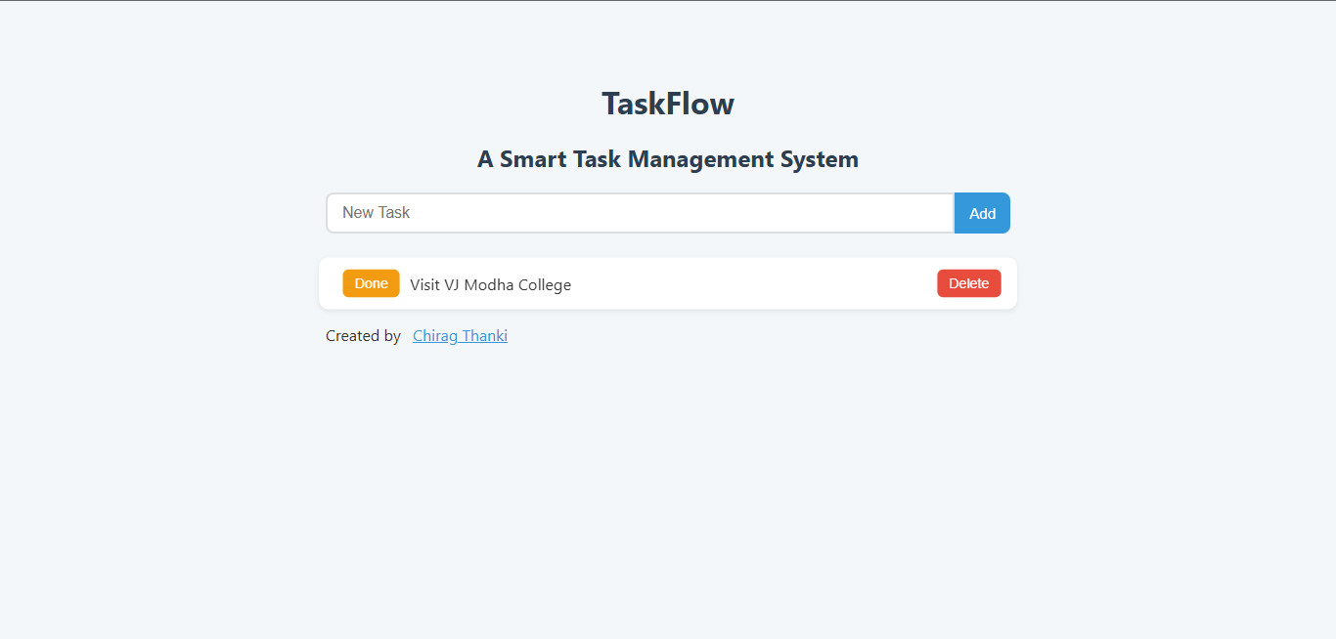

## Home Page (Add Task)

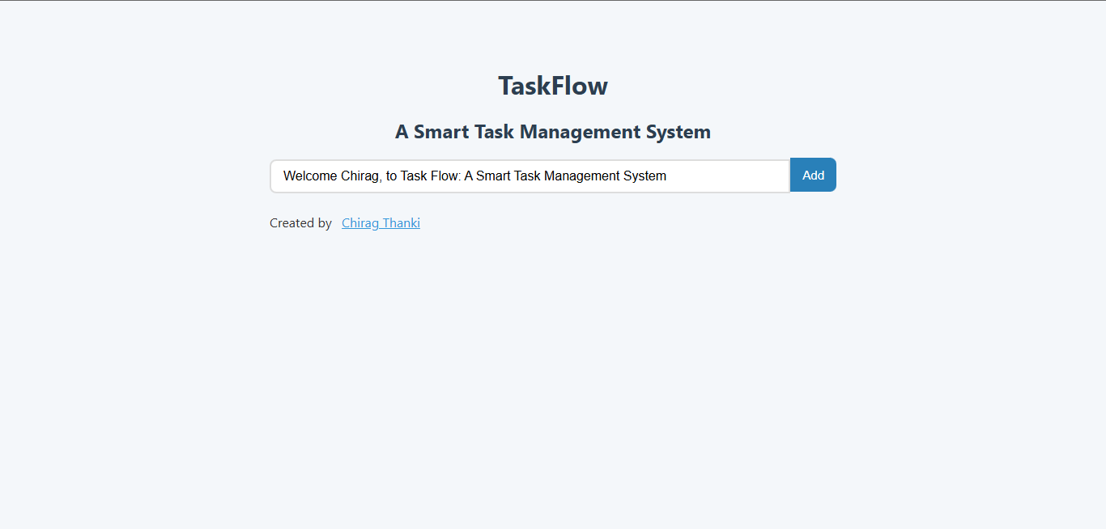

## Home Page (Added Task)

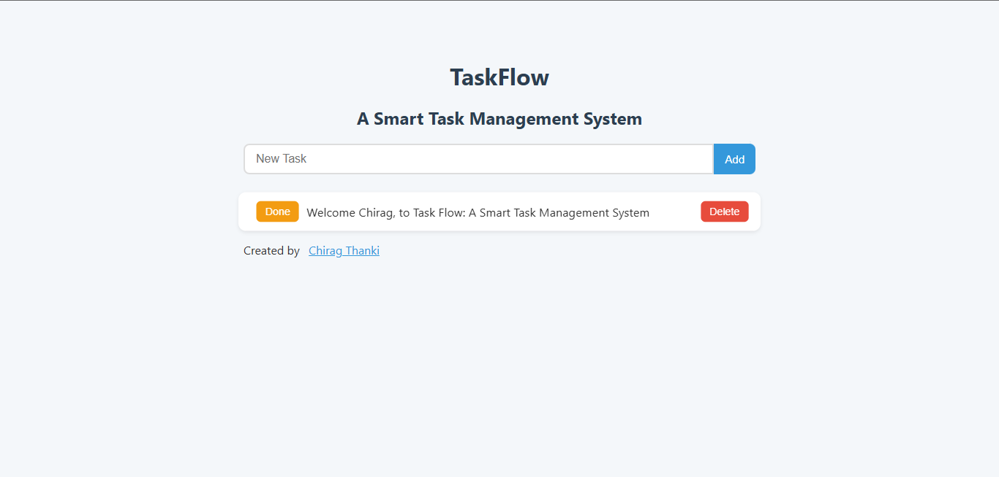

## Home Page (Multiple Tasks Added)

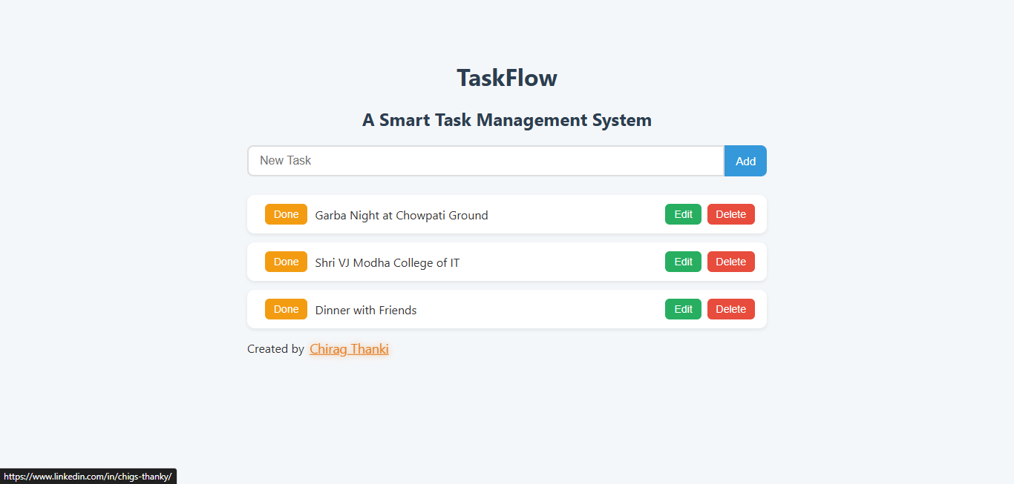

## Home Page (Completed Tasks)

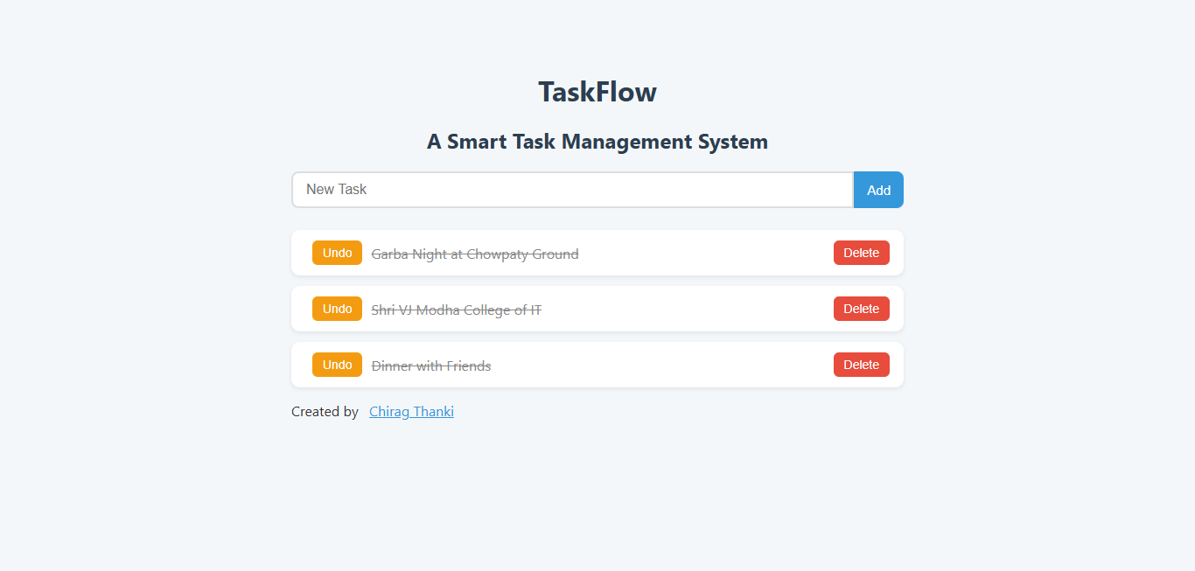

## Home Page (Edit/Update Tasks)

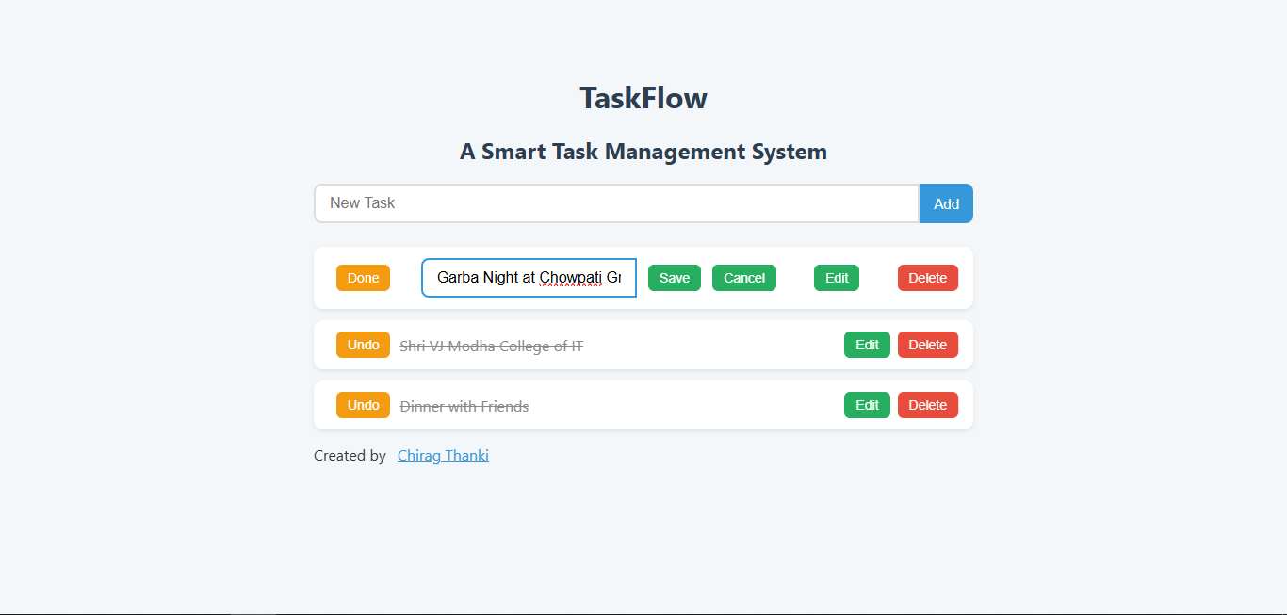

## Home Page (My Link Highlighted)



## Home Page (Tasks List with done tasks)

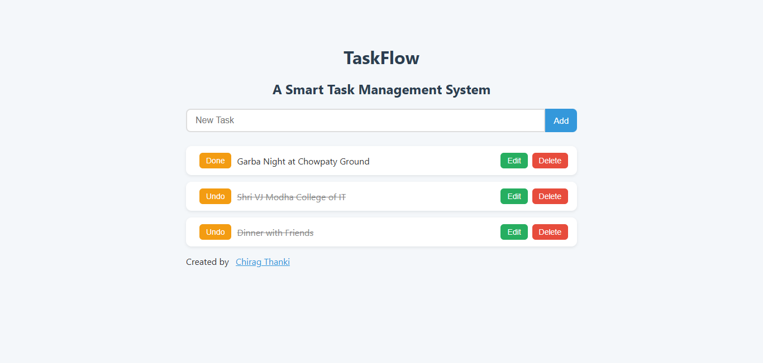

# Server-Side (BackEnd)

## Server.js (Node.js server file):

const express = require("express");

const mongoose = require("mongoose");

const bodyParser = require("body-parser");

const Todo = require("./models/Todo");

const app = express();

// Middleware

app.use(bodyParser.urlencoded({ extended: true }));

app.set("view engine", "ejs");

app.use(express.urlencoded({ extended: true }));

// Connect MongoDB

mongoose.connect("mongodb://127.0.0.1:27017/todo_app", {

useNewUrlParser: true,

useUnifiedTopology: true,

});

// Routes

app.get("/", async (req, res) => {

const todos = await Todo.find();

res.render("index", { todos });

});

app.post("/add", async (req, res) => {

const newTodo = new Todo({ task: req.body.task });

await newTodo.save();

res.redirect("/");

});

// Update Task

app.post("/update/:id", async (req, res) => {

const { task } = req.body;

await Todo.findByIdAndUpdate(req.params.id, { task: task });

res.redirect("/");

});

// Delete Task

app.post("/delete/:id", async (req, res) => {

await Todo.findByIdAndDelete(req.params.id);

res.redirect("/");

});

app.post("/toggle/:id", async (req, res) => {

const todo = await Todo.findById(req.params.id);

todo.completed = !todo.completed;

await todo.save();

res.redirect("/");

});

// Start server

app.listen(3000, () => console.log("Server running on http://localhost:3000"));

## app.js (Node.js server file):

const mongoose = require("mongoose");

const TodoSchema = new mongoose.Schema({

task: { type: String, required: true },

completed: { type: Boolean, default: false }

});

module.exports = mongoose.model("Todo", TodoSchema);

## index.ejs (FrontEnd file):

<!DOCTYPE html>

<html>

<head>

<title>Chirag Thanki</title>

<link rel="shortcut icon" href="/views/favicon.png" type="image/x-icon">

//Inline CSS

<style>

body {

font-family: 'Segoe UI', Tahoma, Geneva, Verdana, sans-serif;

max-width: 700px;

margin: 40px auto;

padding: 20px;

background: #f4f7fa;

color: #333;

}

h1,

h2 {

text-align: center;

margin-bottom: 20px;

color: #2c3e50;

}

form[action="/add"] {

display: flex;

justify-content: center;

margin-bottom: 25px;

}

input[type="text"] {

flex: 1;

padding: 10px 15px;

border: 2px solid #ddd;

border-radius: 8px 0 0 8px;

font-size: 16px;

outline: none;

transition: border 0.3s;

}

input[type="text"]:focus {

border-color: #3498db;

}

button {

padding: 10px 15px;

border: none;

background: #3498db;

color: white;

font-size: 15px;

border-radius: 0 8px 8px 0;

cursor: pointer;

transition: background 0.3s, transform 0.2s;

}

button:hover {

background: #2980b9;

transform: translateY(-2px);

}

ul {

list-style: none;

padding: 0;

}

li {

display: flex;

align-items: center;

justify-content: space-between;

background: white;

padding: 12px 16px;

margin-bottom: 12px;

border-radius: 10px;

box-shadow: 0 2px 5px rgba(0, 0, 0, 0.08);

transition: transform 0.2s;

}

li:hover {

transform: scale(1.02);

}

.completed {

text-decoration: line-through;

color: #888;

}

li form {

display: inline;

}

li button {

background: #27ae60;

border-radius: 6px;

margin-left: 8px;

padding: 6px 12px;

font-size: 14px;

}

li button:hover {

background: #1e8449;

}

li form[action*="delete"] button {

background: #e74c3c;

}

li form[action*="delete"] button:hover {

background: #c0392b;

}

li form[action*="toggle"] button {

background: #f39c12;

}

li form[action*="toggle"] button:hover {

background: #d68910;

}

span {

flex: 1;

margin: 0 10px;

font-size: 16px;

}

a {

display: inline-block;

font-size: 16px;

color: #3498db;

transition: all 0.3s ease-in-out;

}

a:hover {

transform: scale(1.1);

color: #e67e22;

text-shadow: 0 0 8px rgba(230, 126, 34, 0.7);

}

</style>

</head>

<body>

<h1>TaskFlow</h1>

<h2>A Smart Task Management System</h2>

<form action="/add" method="POST">

<input type="text" name="task" placeholder="New Task" required />

<button type="submit">Add</button>

</form>

<ul>

<% todos.forEach(todo=> { %>

<li>

<!-- Toggle -->

<form action="/toggle/<%= todo._id %>" method="POST" style="display:inline;">

<button type="submit">

<%= todo.completed ? "Undo" : "Done" %>

</button>

</form>

<!-- Task text -->

<span id="text-<%= todo._id %>" class="<%= todo.completed ? 'completed' : '' %>">

<%= todo.task %>

</span>

<!-- Hidden update form -->

<!-- <form id="form-<%= todo._id %>" action="/update/<%= todo._id %>" method="POST" style="display:none;">

<input type="text" name="task" value="<%= todo.task %>" required />

<button type="submit">Save</button>

<button type="button" onclick="cancelEdit('<%= todo._id %>')">Cancel</button>

</form> -->

<!-- Edit + Delete -->

<!-- <button type="button" onclick="editTask('<%= todo._id %>')">Edit</button> -->

<form action="/delete/<%= todo._id %>" method="POST" style="display:inline;">

<button type="submit">Delete</button>

</form>

</li>

<% }) %>

</ul>

<footer>

<p>Created by &ensp;<a href="https://www.linkedin.com/in/chigs-thanky/" target="_blank">Chirag Thanki</a></p>

</footer>

<script>

function editTask(id) {

document.getElementById("text-" + id).style.display = "none";

document.getElementById("form-" + id).style.display = "inline";

}

function cancelEdit(id) {

document.getElementById("text-" + id).style.display = "inline";

document.getElementById("form-" + id).style.display = "none";

}

</script>

</body>

</html>

# Database (MongoDB):

DB showing Pending tasks (completed: false (Boolean)

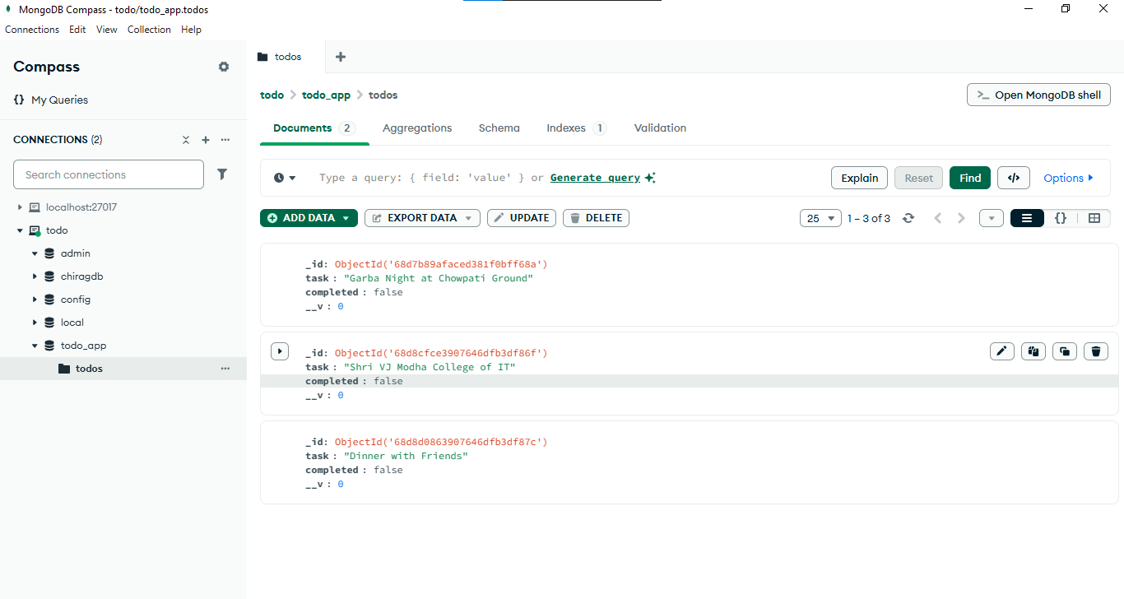

DB showing Done tasks (completed: true (Boolean)

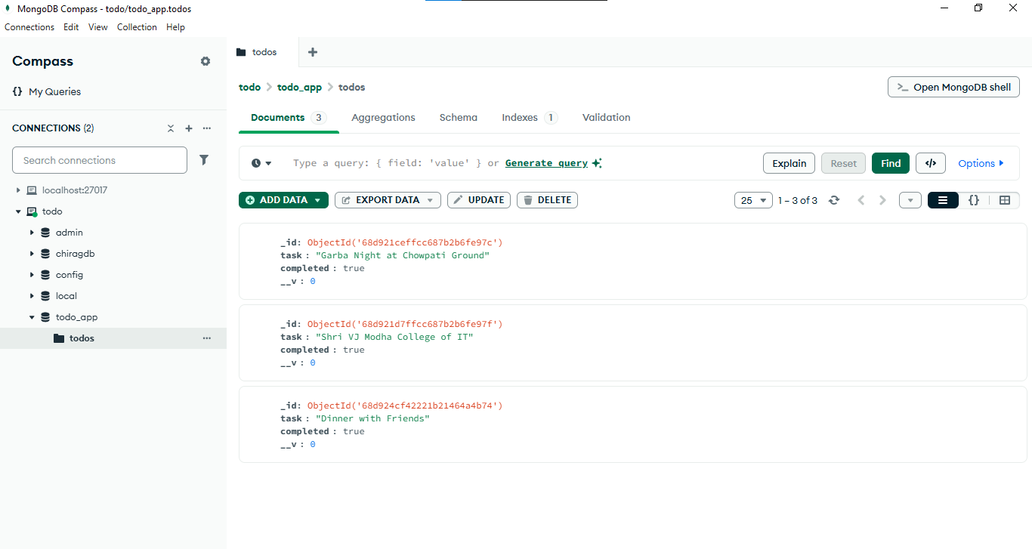

# Budget and Financial Plan

Building the TaskFlow to-do list app will require some initial development investment. If you hire a freelance developer in India at around ₹1,500–₹4,000 per hour, the cost of building a minimum viable product (MVP) could range from ₹1,00,000 to ₹3,00,000 depending on the complexity of features and UI design. Additional expenses for UI/UX design may cost ₹15,000–₹40,000, and project management or testing could add another ₹15,000–₹40,000.

For infrastructure, hosting the app can be relatively inexpensive at the start. A virtual server on providers like DigitalOcean, AWS, or Render will cost about ₹400–₹1,500 per month. MongoDB Atlas offers a free tier, but for production you may spend ₹800–₹2,000 per month. A domain name will cost around ₹800–₹1,200 per year, and SSL certificates can be free with Let’s Encrypt. Overall, monthly infrastructure costs will likely fall between ₹800 and ₹4,000 in the early stages.

Marketing is essential for growth. A modest advertising budget on social platforms like Facebook, LinkedIn, or Instagram may run ₹8,000–₹40,000 per month, while SEO and content marketing could cost ₹4,000–₹15,000. If you decide to publish a mobile app later, there is a one-time Google Play fee of ₹2,000 and a yearly Apple Developer fee of around ₹8,000. Altogether, marketing may require ₹12,000–₹60,000 per month, depending on your growth goals.

Ongoing maintenance should also be factored in. Expect around ₹20,000–₹40,000 per month for bug fixes and small updates, and ₹40,000–₹1,50,000 for larger feature expansions such as notifications, team collaboration, or reminders. Hosting and database costs will also rise as user traffic increases, ranging from ₹4,000 to ₹40,000 per month for scaling.

For revenue, you can adopt a freemium model where the basic to-do list remains free, and advanced features like reminders, team tasks, or themes are offered as a premium upgrade at ₹250–₹400 per month. Another option is a team or business plan, charging around ₹150 per user per month for collaboration tools. Advertising is also possible in a free version, though revenue from ads tends to be modest.

To break even, assuming monthly costs of ₹8,000–₹15,000, you only need 40–60 premium subscribers paying ₹300 per month. With steady growth, if TaskFlow reaches 5,000 users by month six and converts 4% into premium users, revenue could reach around ₹1,00,000 per month with ₹25,000 in expenses, generating about ₹75,000 profit. By the end of year one, with 20,000 users and a 5% conversion rate, TaskFlow could bring in around ₹4,00,000 monthly revenue against ₹65,000 expenses, resulting in over ₹3,00,000 profit per month.

In summary, the app has low infrastructure costs and a clear path to profitability with even modest user adoption. Careful investment in development and steady marketing could allow TaskFlow to become sustainable within 6–12 months.

# Future Enhancements

Every project has certain limitations due to technological, time, and resource constraints. *TaskFlow: A Smart Task Management System* is a reliable and efficient solution for managing daily tasks, but there are a few areas where improvements can be made to increase its overall performance, scalability, and user experience.

To make TaskFlow more robust and user-friendly, several improvements can be introduced in future versions:

**1. Role-Based Access Control (RBAC):**

Implementing user roles such as Admin, Manager, and Employee will allow better control over task creation, modification, and deletion, ensuring secure collaboration in a team environment.

**2. Enhanced User Interface:**

The UI can be redesigned with modern frameworks like React or Angular for a more intuitive and visually appealing experience. Features like drag-and-drop task organization, real-time updates using WebSockets, and dark mode could be added.

**3. Offline Mode with Synchronization:**

Adding offline support will allow users to create and edit tasks without an internet connection, and the system will automatically sync changes when the connection is restored.

**4. Integration with External Tools:**

Connecting TaskFlow with Google Calendar, Microsoft Teams, or Slack will help users receive reminders and updates directly within their preferred productivity platforms.

**5. Improved Security:**

Implementing encryption, JWT-based authentication, and two-factor authentication will enhance data security and user trust.

**6. Analytics and Reporting:**

Adding dashboards and task completion statistics will allow users to track productivity and gain insights into performance trends.

**7. Mobile Application:**

Developing a mobile-friendly version or dedicated app will improve accessibility and make TaskFlow convenient for users on the go.

As technology continues to evolve, there are several potential areas for improving and extending the functionality of **TaskFlow: A Smart Task Management System**. While the current system successfully implements basic CRUD (Create, Read, Update, Delete) operations using Node.js and MongoDB, future enhancements could make the application more robust, user-friendly, and scalable for a wider audience.

One of the primary future enhancements could be **user authentication and role-based access control**. Currently, tasks can be created, updated, or deleted without user-specific restrictions. By implementing a secure login system with features such as JWT (JSON Web Tokens) or OAuth, users could have their own personalized accounts. Role-based access, such as admin, manager, and regular user, would add an extra layer of security and ensure that sensitive data is accessed only by authorized individuals.

Another major enhancement could be the addition of **real-time updates and notifications**. Using technologies such as WebSockets or Socket.io, users could receive instant notifications when tasks are created, updated, or assigned to them. This feature would be particularly useful for teams collaborating on projects, as everyone would stay updated without needing to refresh the page. Push notifications could also be integrated for mobile and desktop devices, making the system more interactive and efficient.

To improve usability, **a more advanced task categorization and filtering system** could be introduced. Users could tag tasks with priorities, deadlines, or project categories, making it easier to sort and search through large lists of tasks. Additionally, features like drag-and-drop task management or a Kanban board view could provide a more visual and intuitive way to organize work.

From a technical perspective, scalability is an important consideration. Future versions of TaskFlow could integrate **cloud deployment and containerization** using platforms like Docker and Kubernetes. This would allow the application to handle a higher number of users and requests efficiently, ensuring smooth performance even during peak usage. Similarly, implementing database indexing and caching strategies could improve query performance and reduce response times.

Another possible enhancement is **integration with third-party services** such as Google Calendar, Slack, or Microsoft Teams. This would enable users to synchronize deadlines, receive reminders, and collaborate seamlessly across multiple platforms. An API could also be developed to allow other systems to interact with TaskFlow, opening the door for automation and extended use cases.

Lastly, the future roadmap could include **AI-powered features**, such as smart task recommendations, deadline predictions, and workload balancing based on user behavior. Machine learning models could analyze task history and suggest ways to improve productivity, making TaskFlow not just a management tool but also an intelligent assistant for teams.

In summary, the future of TaskFlow holds significant potential for growth. By adding authentication, real-time notifications, better task organization, scalability, third-party integrations, and AI-driven insights, the system can evolve into a comprehensive, intelligent, and user-friendly task management solution.

# Limitations

**1. Limited User Roles and Permissions:**

Currently, TaskFlow supports basic CRUD operations for tasks but does not offer advanced role-based access control (RBAC). All users have similar permissions, which might not be suitable for large organizations where different user roles such as admin, manager, and employee are required.

**2. Basic UI and UX Design:**

The system interface is functional but minimal. While it supports core operations like create, read, update, and delete, it lacks advanced design features such as drag-and-drop task management, customizable themes, or real-time notifications, which are essential for a modern task management tool.

**3. No Offline Support:**

The application depends entirely on an active internet connection to interact with the MongoDB database. Users cannot create or update tasks offline, which could limit usability in areas with unstable internet connectivity.

**4. Scalability Constraints:**

Since the project is built as a basic prototype, it has not been stress-tested for high volumes of concurrent users or tasks. As a result, performance might degrade if the system is used in a large-scale enterprise environment with thousands of tasks being updated simultaneously.

**5. Limited Integrations:**

TaskFlow is currently a standalone system and does not integrate with third-party productivity tools such as Google Calendar, Slack, or email reminders. This makes it less convenient for users who rely on multiple tools to manage their workflow.

**6. Security Concerns:**

Although basic data validation is implemented, advanced security measures such as encryption of sensitive data, two-factor authentication, and detailed audit logs are not yet integrated, which could pose a risk for data privacy in real-world use.

# Conclusion

The development of **TaskFlow: A Smart Task Management System** marks a significant step toward building a practical, efficient, and user-friendly solution for managing tasks in an organized manner. The primary goal of this project was to simplify the process of task creation, monitoring, and management by providing a robust web-based platform where users can perform essential **CRUD operations** (Create, Read, Update, Delete) seamlessly. Throughout the project, the focus remained on ensuring reliability, scalability, and ease of use while implementing the system’s core functionalities.

This project leverages **Node.js** as the server-side technology, offering asynchronous, event-driven architecture that allows smooth handling of multiple requests, resulting in better performance and responsiveness. By using **MongoDB** as the database, TaskFlow takes advantage of a flexible, schema-less NoSQL structure, making data handling faster and easier to scale. The CRUD operations implemented in the system ensure that users can efficiently add new tasks, retrieve existing tasks for review, update task details, and delete completed or unnecessary tasks. This modular approach improves both usability and maintainability, allowing future enhancements to be integrated with minimal effort.

During the development phase, attention was given to building a clean and interactive user interface that ensures a positive user experience. Special care was taken to handle errors gracefully, ensuring that invalid data inputs, failed connections, or missing tasks are properly managed. This not only enhances the reliability of the system but also ensures that users can trust TaskFlow for their daily productivity needs.

The project also emphasizes scalability and real-world adaptability. Since task management is an integral part of both personal and professional workflows, the system has been designed to handle multiple users and growing datasets effectively. Its modular code structure and API-driven design allow easy integration with other tools or future features such as user authentication, task categorization, reminders, and collaborative task sharing.

In conclusion, **TaskFlow** successfully demonstrates how modern web technologies like Node.js and MongoDB can be combined to create a lightweight yet powerful task management solution. It not only meets the objective of implementing CRUD operations but also provides a foundation for future improvements and advanced features. By focusing on simplicity, performance, and scalability, the project delivers a robust platform that can help users stay organized, improve productivity, and achieve their goals efficiently. The knowledge and skills gained from building this project can be further applied to more complex systems, showcasing the potential of full-stack development in solving real-world problems.

# Bibliography

The development of **TaskFlow: A Smart Task Management System** was inspired by several online resources, official documentation, and research papers that contributed to the understanding of Node.js, MongoDB, and CRUD operations. This bibliography lists the references and resources used during the design and implementation of the project.

**Node.js Documentation** – The official Node.js documentation (https://nodejs.org/en/docs/) was a primary reference for understanding the fundamentals of Node.js, including modules, asynchronous programming, event-driven architecture, and HTTP server creation. It provided the base knowledge required to set up the server-side logic for the project and build efficient RESTful APIs for CRUD operations.

**MongoDB Documentation** – The official MongoDB documentation was used extensively to understand database design, schema modeling using Mongoose, and performing operations such as Create, Read, Update, and Delete. This helped in managing tasks efficiently within the database and ensuring scalability of the system.

**Express.js Guide** – The Express.js official website (https://expressjs.com/) was referred to for building robust APIs and middleware integration. Express was used as the backend framework to handle routes, middleware, and HTTP requests efficiently.

**W3Schools and GeeksforGeeks** – Tutorials and articles from W3Schools (https://www.w3schools.com/) and GeeksforGeeks (https://www.geeksforgeeks.org/) were used to clarify specific concepts of JavaScript, Node.js, and REST APIs. These platforms provided examples and explanations that were instrumental in implementing user authentication and request handling.

**Stack Overflow** – Community discussions and solutions from Stack Overflow played a major role in debugging errors and finding best practices for connecting Node.js applications with MongoDB, handling asynchronous calls, and structuring project directories.

**NPM and Open-Source Packages** – The Node Package Manager repository was used to explore and install dependencies like Mongoose, Express, Body-Parser, and Nodemon. Documentation for each package was reviewed to understand proper implementation and configuration.

**GitHub Repositories and Sample Projects** – Several open-source task management projects on GitHub were studied to analyze different approaches to CRUD implementation and user interface design. These references helped in structuring a maintainable and scalable codebase for TaskFlow.

**Research Articles and Blogs** – Articles on modern task management systems and productivity tools were referred to, which provided insights into features like categorizing tasks, setting deadlines, and improving user experience.

# References

* I am thankful to my guide **Dr. Jyotsna Salet** for guiding me. I am also thankful to whole staff of the Computer Department for giving me huge support for my project.

## Sites:

* www.google.com
* www.youtube.com
* www.stackoverflow.com

Thank You